sVERSION A: 12 PM CLASS

**EXAM II-Monday November, 2014**

**Chem51A (Dong-Weiss)**

**Instructions:** You may use your **MODEL SETS** and **Table 13.2** shown below. The periodic table is projected on screen. The back pages can be use for scratch paper but answers must be clearly shown in space given. Please make sure you have all SIX pages of this exam, including the cover page. Attempt every problem. Best of luck!

**Time allowed:** 50 minutes.

|  |  |  |
| --- | --- | --- |
| **Question** | **Marks possible** | **Marks Earned** |
| 1. stereochemistry | **26** |  |
| 2. chair conformations | **32** |  |
| 3. Newman projects | **22** |  |
| 4. spectroscopy | **20** |  |
| bonus | **2** |  |
| TOTAL | **100** |  |

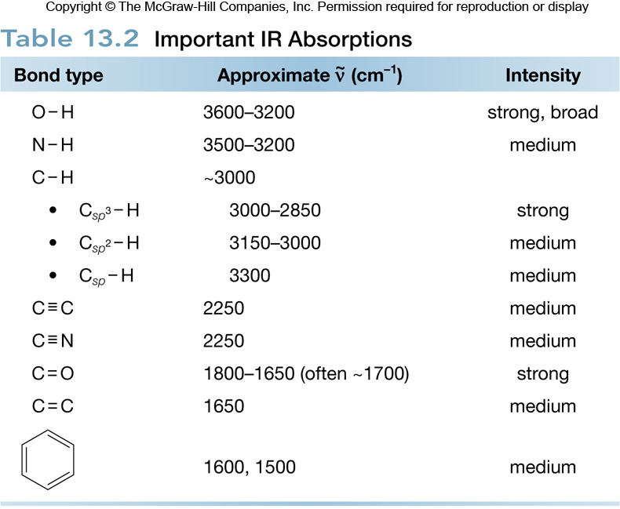

**1.** As an undergraduate student at UC Irvine, Vy did research in the lab of her O-chem professor, Larry Overman. The Overman Lab has synthesized a molecule called (+)-sieboldine A in twenty steps. Answer the following questions. **(26 points)**

4

3

2

1

*

*

*

*

*

*

*

1a. Draw an asterisk (*) next to each stereogenic center in (+)-sieboldine A (4 pts).

1b. How many *stereoisomers* of sieboldine A are possible (4 pts)?

32

1c. What does the positive sign in (+)-sieboldine A mean? (4 pts)

1. This enantiomer has beneficial biological activity.
2. This enantiomer rotates plane-polarized light in the positive direction.
3. This enantiomer has the *R*-configuration.
4. All of the above.
5. Both B and C.

1d. What is the configuration of the stereogenic center indicated by the arrow *R* or *S*? Show how you ranked the atoms in priority. (4 pts)

S

1f. The infrared spectrum for this molecule shows 3398, 2953, 2926, 2870, 1754, 1696, 1455, 1061 cm-1. Circle the wave number(s) that correspond to the **ketone(s)**. (4 pts).

1g. Will the mass/charge (m/z) for this molecule be odd or even? Explain your choice (4 pts).

1h. What will the optical activity be for a racemic mixture of sieboldine A? (2 pts).

The optical rotations of each enantiomer will cancel each other out.

**2.** Answer questions below regarding alkane **1** shown in the box to the right. **(32 points)**

2a. Draw the two chair conformations of **1** using the template below. (10 pts)



2b. Circle the more stable conformation and explain why. (4 pts)

2c. Label ALL the stereocenters as *R* or *S* on alkane **1**. (4 pts)



2d. Is alkane **1** chiral or achiral? (4 pts)

Achiral (there is a mirror plane between the methyl groups)

2e. Draw one constitutional isomer of alkane **1**. (4 pts)



2f. Draw all of the *stereosiomers* of alkane **1**. (10 pts)

 (The other cis isomer would be an identical molecule)

**3.** Answer questions about molecule **2** shown (**22 points**).

3a. Circle one. Molecule **2** is CHIRAL or ACHIRAL? (2 pts)

3b. Circle the correct IUPAC name for this molecule. (4 pts)

(*R*)-2-butylbromide (*S*)-2butylbromide

(*R*)-2-bromobutane (*S*)-2-bromobutane

3c. Draw the Newman projection of the conformation shown, looking down the C2-C3 bond. (6 pts)



3d. Is the conformation STAGGERED or ECLIPSED? (2 pts)

3e. Draw a constitutional isomer of this molecule. (4 pts)



3f. Draw the enantiomer of molecule **2** using the template below (4 pts).





**BONUS:** How would you separate a mixture of enantiomers? (2 pts)

Chiral chromatography

4. Answer questions about mass spectrometry and infrared spectroscopy (**20 points**)

|  |  |  |
| --- | --- | --- |
| 4a. | In electron impact mass spectrometry (EIMS), what is being detected? (2pts) | |
| A) | The molecular mass of the compound |
| B) | The molecular formula of the compound |
| C) | The mass to charge ratio of any ionic species |
| D) | The mass to charge ratio of any neutral species |

|  |  |  |  |  |
| --- | --- | --- | --- | --- |
| 4b. Zhiwei observes a compound that exhibits a mass spectrum with a peak at 160 and a peak at 162, both of equal intensity. This compound contains (2pts): | | | | |
| A) | Two chlorine atoms | C) | One bromine atom | |
| B) | One iodine atom | D) | Two bromine atoms | |

**Explain your answer** (4 pts):

|  |  |
| --- | --- |
| 4c. | Which of the indicated C–H bonds absorbs at the lowest wave number in the IR spectrum? (2pts)  **Explain why based on s-character** (4 pts): |

|  |  |
| --- | --- |
| 4d. | Which of these ketones will have the lowest wavenumber for carbonyl absorption? (2 pts) |
|  |  |

**Explain why and use resonance structure(s) to support your answer.** (4 pts)